

**CSE 2046**

**ANALYSIS OF ALGORITHMS**

**HOMEWORK 2**

**REPORT**

**STUDENT NAME: ID:**

Yasin Tarakçı 150118055

Yusuf Taha Atalay 150119040

Ahmet Emre Sağcan 150119042

**Submitted To :**  Ömer Korçak

**DESCRIBING OUR PROGRAM**

**1.Taking the Input and Output File:**

User is asked to enter the name of the input and output file.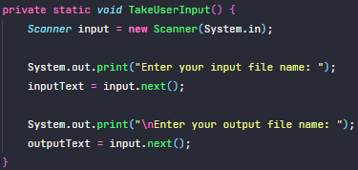

**2.Reading the Input File:**

This part reads the input file according to the input format. We store items with their properties on an Item object. Then move them into an items array. Also we store capacities of each constraint on a capacities array.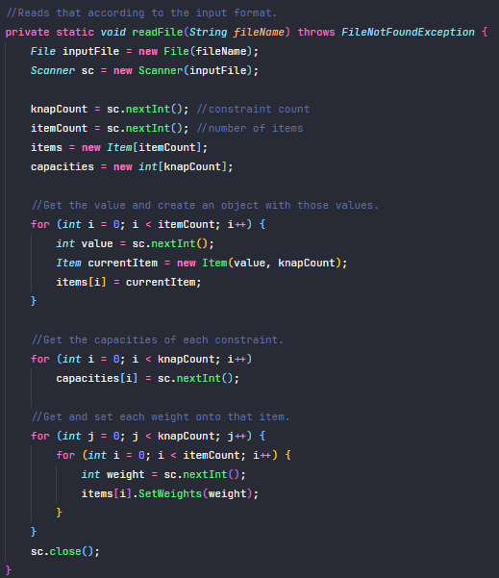

**3.Sorting the Item Array by a Ratio:**

First of all, we sort the array. We are sorting items by their average ratios. When the program is setting the weights of that object, the program also calls the SetAvgRatio() method in that class. It basically sums up the weights of each constraint and then divides it by that object’s value. After that; when the sort method is called, compareTo is comparing their avgRatios. Then we have an array that has its elements sorted in a decreasing way.

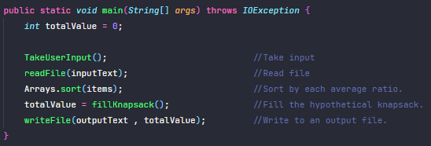

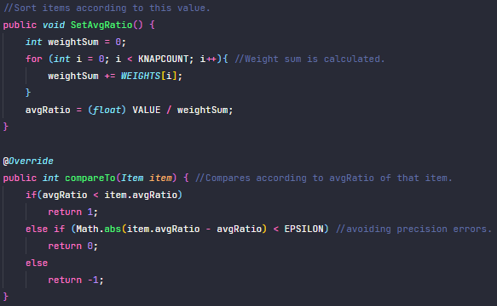

**4.Filling the Knapsack:**

Our algorithm works with O(nm) time complexity where n is number of items, m is number of constraints.For each item in the sorted items array, we do the following:

1. Check if that item is gonna exceed the boundaries of at least one constraint by adding to the weightSum value of that constraint.
2. If it exceeds, go on with the next item.
3. If not:
   1. Add that item to the knapsack (set as 1)
   2. Update the weightSum of each constraint
   3. Go on with calculating total value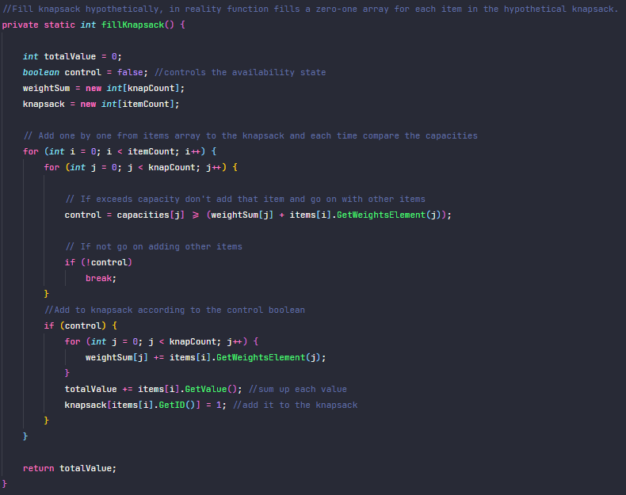

**5.Writing to the Output File:**

Writes to the output file according to the output format.